Lab 2: Filtering

EEE4514

February 8, 2017

**Gabriel Stroe**

**Shawn Baumgartner**

# Filtering

## Overview

The purpose of this lab is to create a system where the high frequency components of a signal will be filtered out creating a very smooth output curve as a result.

## Theory and Methods

The filter we are using for this lab is a simple first order system: 50/(s + 50). This lab will use the basics of setting up the Quarc Servo while sending and receiving signals to the servo motor. The general for of this formula is represented as ω /(s + ω) where ω is the cutoff frequency.

## Results

The low pass filter proves to work correctly as can be shown from the encoder speed graph bellow. The results seem very close the expected results with a few minor spikes that are mostly likely do the mechanical differences and measurement tolerances after filtering. Decreasing the cut off frequency will improve this even further while increasing it increase the sharpness of the curve and adding more “noise” to the output.

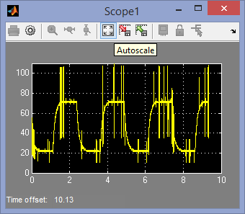

Unfiltered Output

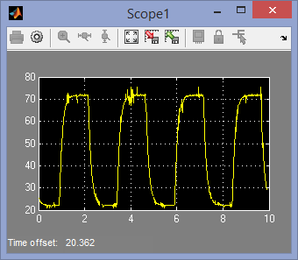

Filtered at ω = 50

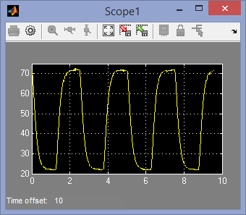

Filtered at ω =10

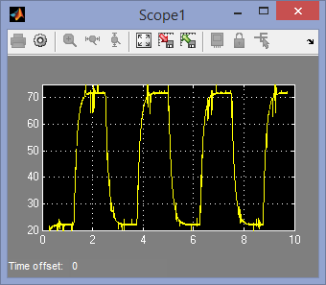

Filtered at ω = 100

## Questions

1. What was the value of your gain?
   1. Our gain was set to 1 as there was now need to increase this value with the current signal generator.
2. Explain the why the encoder-based measurement is noisy.
   1. This has to do with the measurement tool of the device not having a completely continuous method of finding the current velocity of the device. The tool somewhat jumps as the sensor sees the plate rotate to a new slot. This will appear as nose as the next slit comes in front of the sensor.
3. Build and run the QUARC controller. Show the filtered encoder-based speed response and the motor voltage. Has it improved?
   1. Yes the filtering dramatically improved the noise. There is still a small amount that is still present but the filter really reduced this.
4. What is the cutoff frequency of the low-pass filter 50/(s + 50)? Give you answer in both rad/s and Hz.
   1. 50 Hz or about 314 Rad/s.
5. Vary the cutoff frequency, ωf , between 10 to 200 rad/s (or 1.6 to 32 Hz). What effect does it have on the filtered response? Consider the benefit and the trade-off of lowering and increasing this parameter.
   1. Lowering the parameter increases the clarity but also seems to smooth the original curve, increasing the parameter introduces more noise but the peeks also seem to be higher.

## Conclusions

From this lab we have learned that buy using a filter one can significantly reduce the noise inside of a system to allow for a much steadier output. By lowering the filer cutoff value, we can clean up the signal even farther at the cost of smoothing the original curve while increasing the cutoff allows us to increase the peek velocity while introducing some noise to the system.